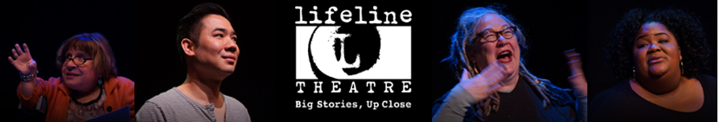
FOR IMMEDIATE RELEASE Photos available HERE
Lifeline Theatre presents 27th Annual Fillet of Solo Festival two-week festival of storytelling performances featuring Jonathan Pitts, Nestor Gomez and more creative artists
January 12-21, 2024
(CHICAGO – December 7, 2023) Lifeline Theatre presents the 27th Annual Fillet of Solo Festival, a vibrant celebration of Chicago's premiere storytelling and live lit scene. The festival spans from January 12-21, 2024, at Lifeline Theatre (6912 N. Glenwood Ave.) and South of The Border (1416 W Morse Ave.) in Chicago's Rogers Park neighborhood. Featuring a diverse array of performers, including a dozen storytelling collectives and numerous solo artists, the festival offers two weeks of powerful personal stories. Spanning comedy, drama, and more – the festival makes up a rich tapestry of Chicago's storytellers.
Fillet of Solo performances take place on Fridays, Saturdays, and Sundays at both venues. See the full festival schedule at www.lifelinetheatre.com. Tickets are $12 for single entry and $60 for a Festival Pass, granting access to any performance. Free parking and shuttle services will be offered.
Festival performances include 80 Minutes Around the World: Immigration Stories with Nestor Gomez, featuring stories of Immigrants, refugees, and asylum seekers; Sweat Girls; Lifeline Storytelling Project; Goodman's GenNarrations; My Dad, His Chimp, and A Serial Killer with Jonathan Pitt; Tellin’ Tales Theatre with Tekki Lomnicki, and more! Full schedule can be viewed at www.lifelinetheatre.com.
A FREE Kick-Off Event will also take place on January 10, 2024 at Rhapsody Theater at 7:00pm where Lifeline Theatre's Ilesa Duncan and Dorothy Milne will guide an evening of performances and conversations with storytellers. The event will provide insights into the festival's history, storytelling forms, and Chicago's dynamic storytelling nights. Festival Passes are available at a discounted rate of $45 during the Kick-Off event (regularly $60).
For more information, contact the Lifeline Theatre Box Office at 773.761.4477 or info@lifelinetheatre.com.
ABOUT LIFELINE THEATRE
Lifeline Theatre is located at 6912 N. Glenwood Ave. in Chicago’s Rogers Park neighborhood. Lifeline is easily accessible by CTA (Red Line Morse stop/buses) and free parking is available at Sullivan High School (6631 N Bosworth Ave, lot located on the corner of Albion and Bosworth) with free shuttle service before and after the show. Street parking is also available. Lifeline is accessible to wheelchair users and visitors who need to avoid stairs.
Founded in 1982, Lifeline Theatre is known for staging innovative adaptations of great works of fiction as well as commissioning original work. In 1987, Lifeline Theatre added KidSeries plays for children and families, and has been producing full seasons of programming for both adults and children ever since. Over the course of forty seasons and over two hundred productions, Lifeline Theatre has made not only an indelible mark on the Chicago theatre scene, but an invaluable contribution to the theatre world at large. Lifeline’s dedicated artistic ensemble has developed one hundred and forty-six world premiere literary adaptations and original plays, nearly forty of which have had a life beyond their Lifeline premieres, with over three hundred subsequent productions spread across over forty U.S. states, six Canadian provinces, plus productions in England, Ireland, Australia, South Africa, and Guatemala. Additionally, four scripts developed at Lifeline Theatre have gone on to U.S. national tours, and over a dozen have been published. Lifeline Theatre has garnered a total of fifty-three Jeff Awards (Equity and Non-Equity), including sixteen for New Adaptation, New Musical, or New Work.
Media contact:
Nicole Rizzo
The Silverman Group, Inc.
nicole@silvermangroupchicago.com
630.631.7156 (cell)

